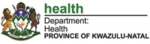
PROVINCIAL GUIDELINE ON CHILD HEALTH SUPERVISION AT PHC LEVEL
Objectives:
- To facilitate quality supervision for child health services at a PHC Level
- To enhance supervisory skills of Health Care Workers for child health services
- To align Child Health Services Supervision with Departmental mandates e.g. Ideal Clinics
- To support implementation of Child Health Programmes at a PHC Level
Process:
On Monthly Basis:
- The facility Operational Managers should conduct Supervision for Child Health Programme e.g. IMCI, EPI on monthly basis using the PHC Supervisory tool and IMCI Case management tool
- Identified gaps should be recorded and an action plan developed and monitored timeously
- A report re- gaps identified should be compiled and forwarded to the PHC Coordinator
On quarterly basis:
- The PHC Coordinator should conduct child health Supervision using the PHC Tools and the IMCI Supervisory Tools, also checking on the competency of IMCI Case management
- This must be in line with the report compiled by the Operational Manager
- Both the Operational Manager and the PHC Coordinator should compile a report to be forwarded to the District
On 6 monthly basis
- The District MCWH Coordinator or District PHC Coordinator should accompany the PHC Supervisor to monitor the progress on challenges and gaps identified and come up with solutions

The Family Physicians, District Clinical Specialist Paeds, District Clinical Specialist PHC, and the District Dietician should divide the number of facilities in the district and allocate themselves the facilities for supervision at least 3 times a week
District Team member | Number of visits | Facilities to visit
MCWH Coordinator | ? 4 visits per month | Regional Hospital; District Hospital; CHC's and Clinics preferably the visit should coincide with the perinatal meetings at the facilities to optimise time spend at facility
DCST Paediatrician | 15 visits per month | Regional Hospital; District Hospital; CHC's and gateway clinics at hospitals
DCST Paediatric Nurse | 15 visits per month | Regional Hospital; District Hospital; CHC's and gateway clinics at hospitals
DCST Family Physician | 15 visits per month | Clinics concentrating on the clinics with the highest number of children seen and clinics with challenges identified by PHC supervisors
DCST PHC nurse | 15 visits per month | Clinics concentrating on the clinics with the highest number of children seen and clinics with challenges identified by PHC supervisors

The Provincial Child Health Team: Should conduct Child Health support visits in the facilities
- when challenges are identified that districts cannot resolve,
- To conduct facility evaluation, if there is poor progress in the indicators or
- Per invitation by the District Coordinators.
- During National or Provincial Campaigns
Please note:
- The supervisory work and names & numbers of facilities to be supervised by each Coordinator or Specialist should be in their Performance Agreements for each financial year so that they should be held accountable for the facilities they are supervising
- The additional requirement when advertising for the Operational Managers posts is that they should be IMCI Trained
- The Province and District RTC should ensure the ongoing updates on IMCI for Operational Managers and other PHC Health Workers

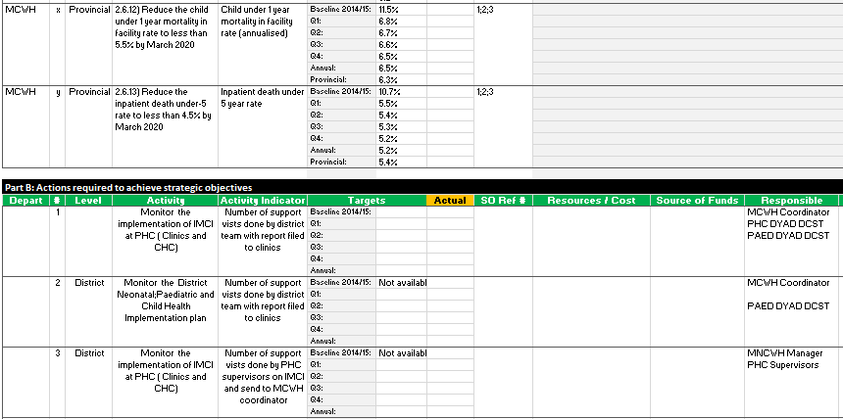
To monitor and evaluate performance of district supervision:
- Quarterly report should include IMCI supervision as an activity to decrease under 1 and under 5 mortality
- All clinics and CHC's should receive 1 IMCI visit per quarter of which a in-depth review every second quarter and reports forward to MCWH coordinator
- Support Visit Report by district team members should be compiled and feedback given at monthly MCWH and DCST meeting and afterwards a copy should be kept for auditing purposes in a MCWH file.

